Imagery of refugees in documentary and photographic
footage
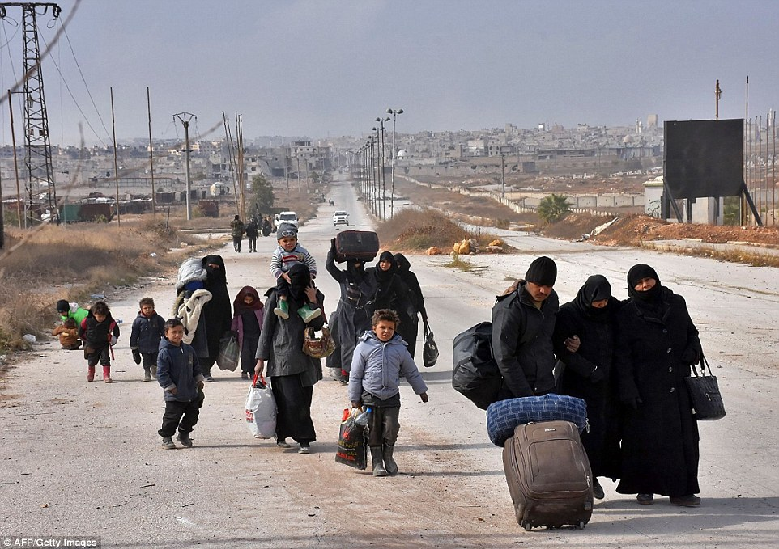
Syria today

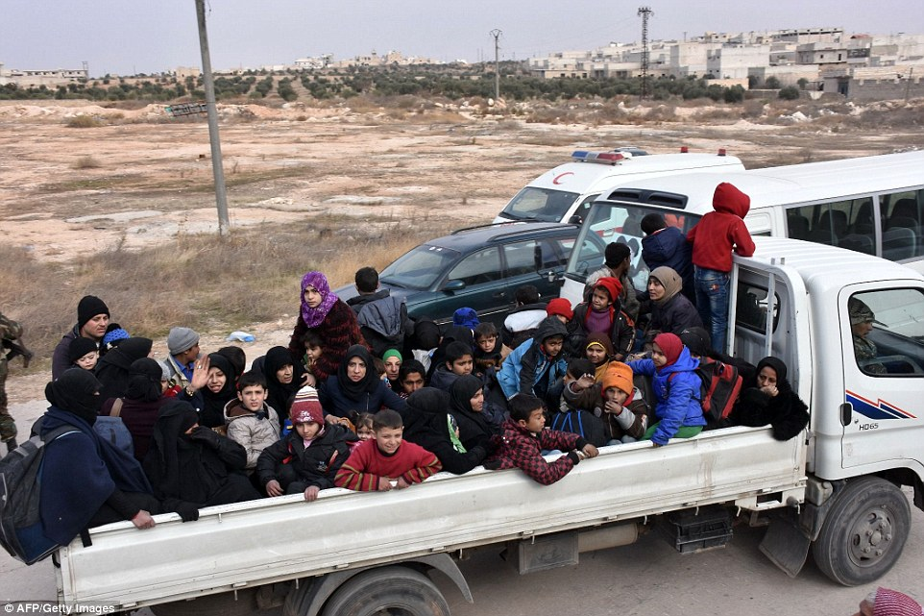
Syria today

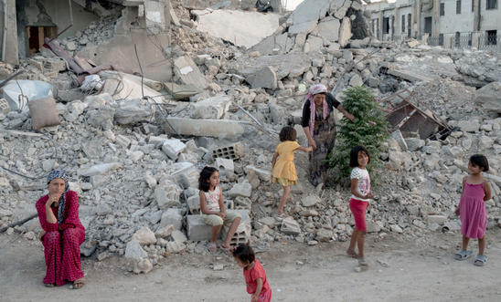
Amnesty International UK The I Welcome Photo Exhibition
27 photos by Magnum photographers, documenting the refugee experience in the 20th and 21st Centuries.
THIS EXHIBITION CAN BE SEEN ONLINE https://www.amnesty.org.uk/i-welcome-photo-exhibition-0 Click on front image to access the Flicker archive of the exhibition
https://www.flickr.com/photos/amnestyuk/sets/72157675943911610

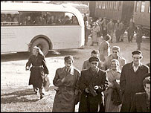Hungary 1956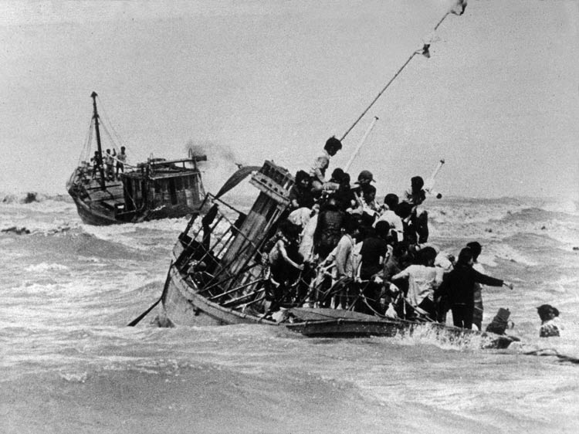 Vietnam 1974 http://vrroom.naa.gov.au/print/?ID=19170
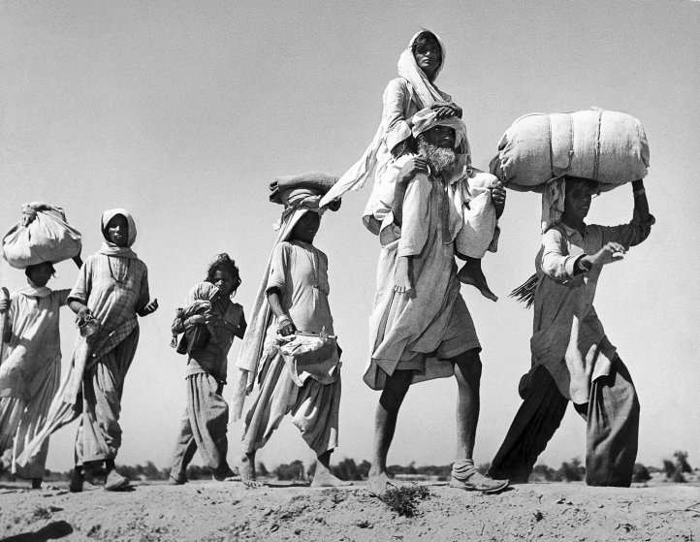
Margaret Bourke-White India 1947
http://time.com/4421746/margaret-bourke-white-great-migration/
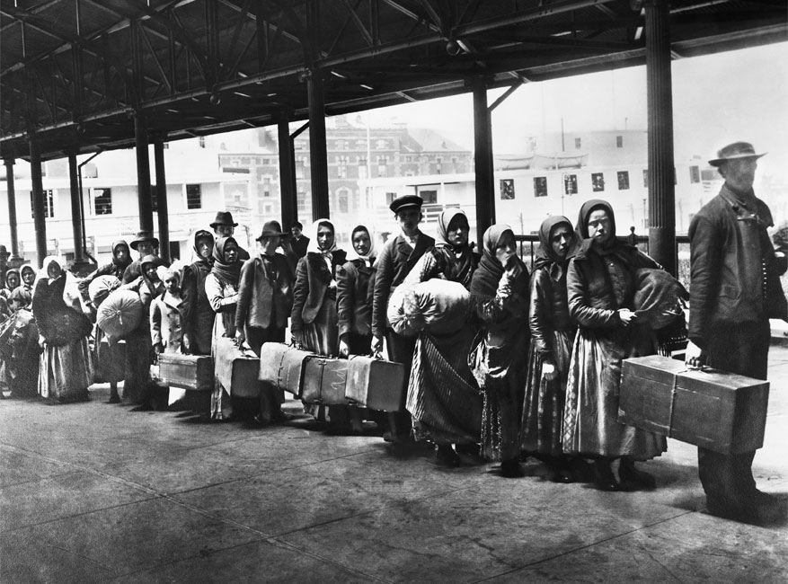
Ellis Island, Immigration reception Centre, New York, 1900s
Interactive Tour: http://teacher.scholastic.com/activities/immigration/tour/

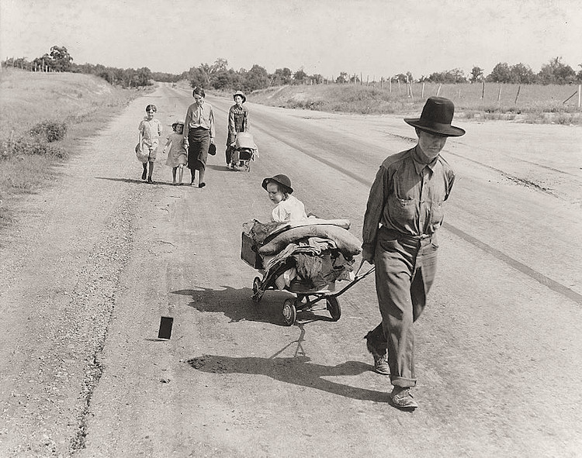
Dorothea Lange, Migrant families, United States, 1930s
http://www.historyplace.com/unitedstates/lange/
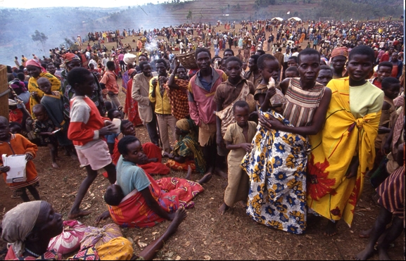
Burundian refugees in Rwanda 1993
http://nsarchive2.gwu.edu/NSAEBB/NSAEBB464/
The Jungle, Calais 1999-2016 BBC Newsbeat
http://www.bbc.co.uk/newsbeat/article/37750368/the-history-of-the-calais-jungle-camp-and-how-its-changed-since-1999

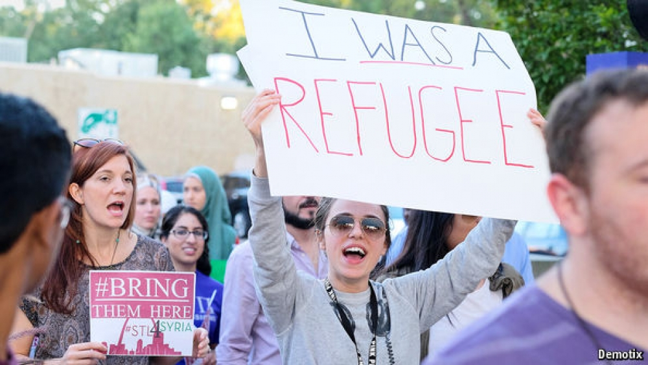
The cycle of immigration: Former Bosnian refugees (1990’s) protesting against US immigration policy in St Louis today
https://www.economist.com/news/united-states/21684143-how-muslim-refugees-bosnia-transformed-corner-midwest-doing-just-fine
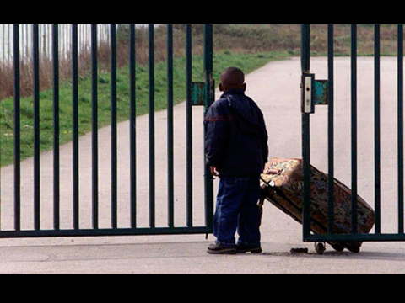

Imagery of refugees
in visual art

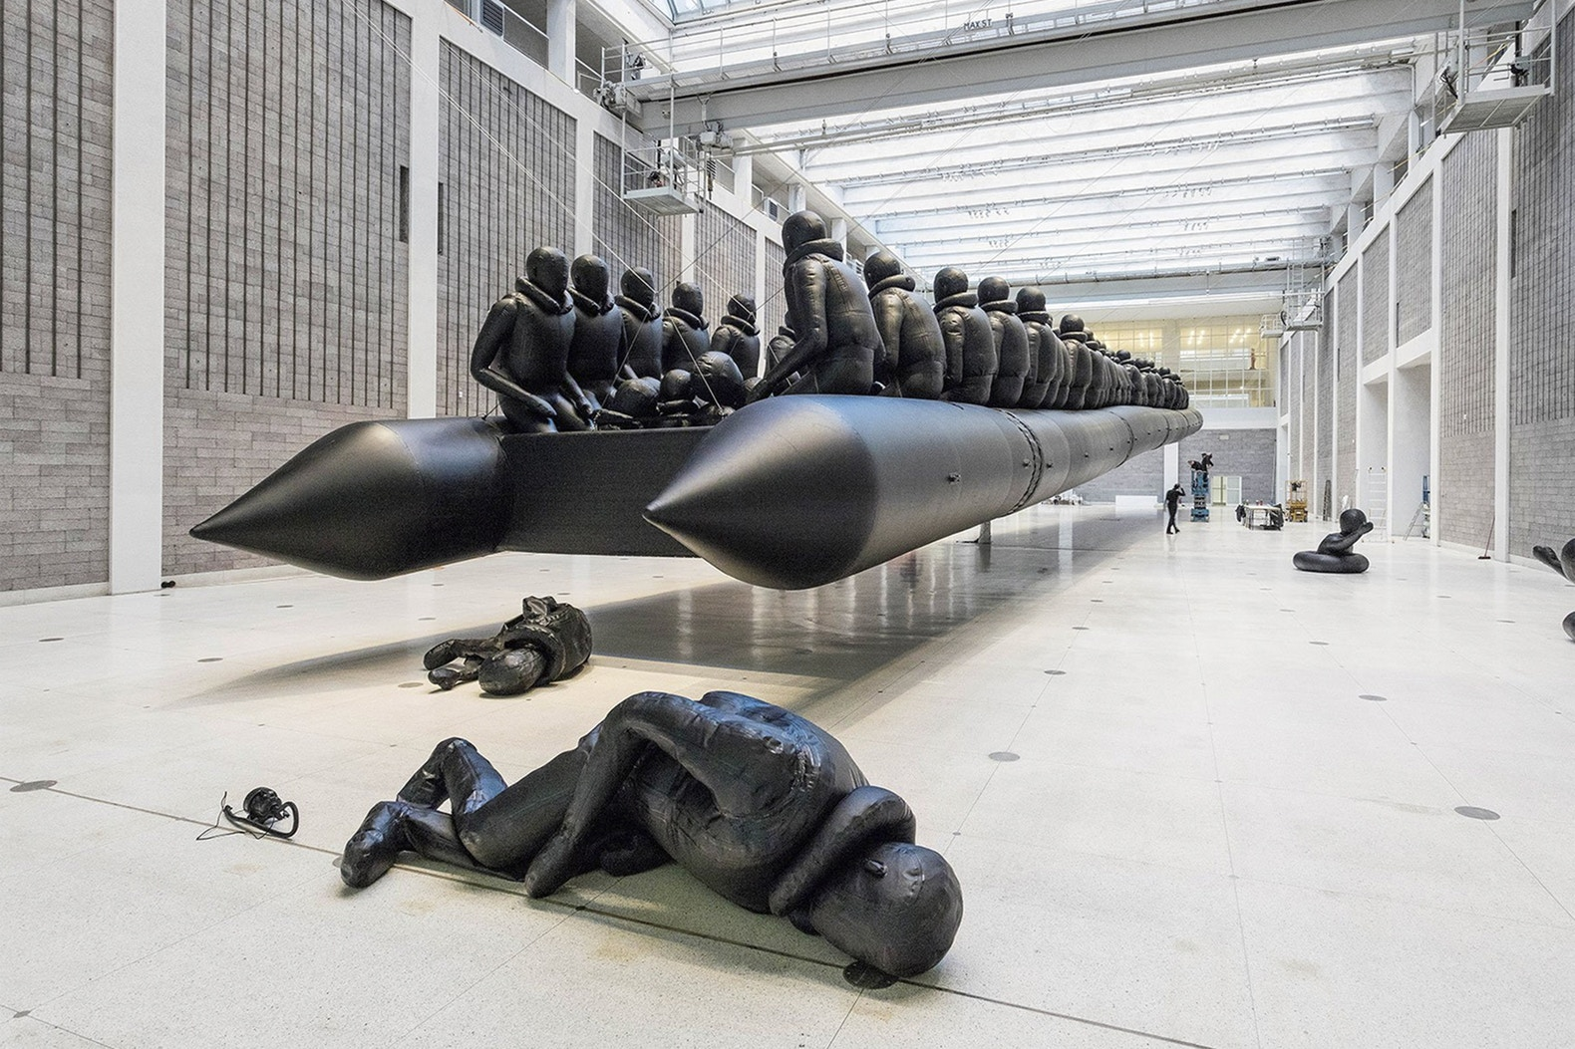
Law of the Journey by Ai Wei Wei 2017
https://hypebeast.com/2017/3/ai-weiwei-law-of-journey-exhibition

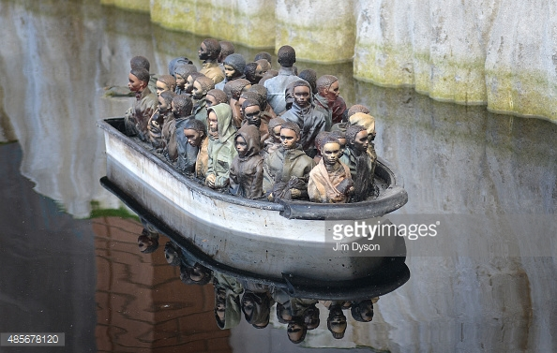
Banksy Refugee Boat in Weston Super Mare Bemusement Arcadehttp://www.gettyimages.co.uk/license/485678120
http://www.gettyimages.co.uk/event/banksys-dismaland-bemusement-park-opens-in-weston-super-mare-574149827#remote-controlled-boat-by-banksy-depicts-migrants-at-the-white-cliffs-picture-id485678120
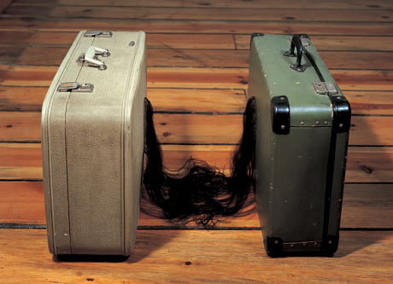
Mona Hartoum Traffic 3, 2002 https://lesconcepts.wordpress.com/tag/mona-hatoum/

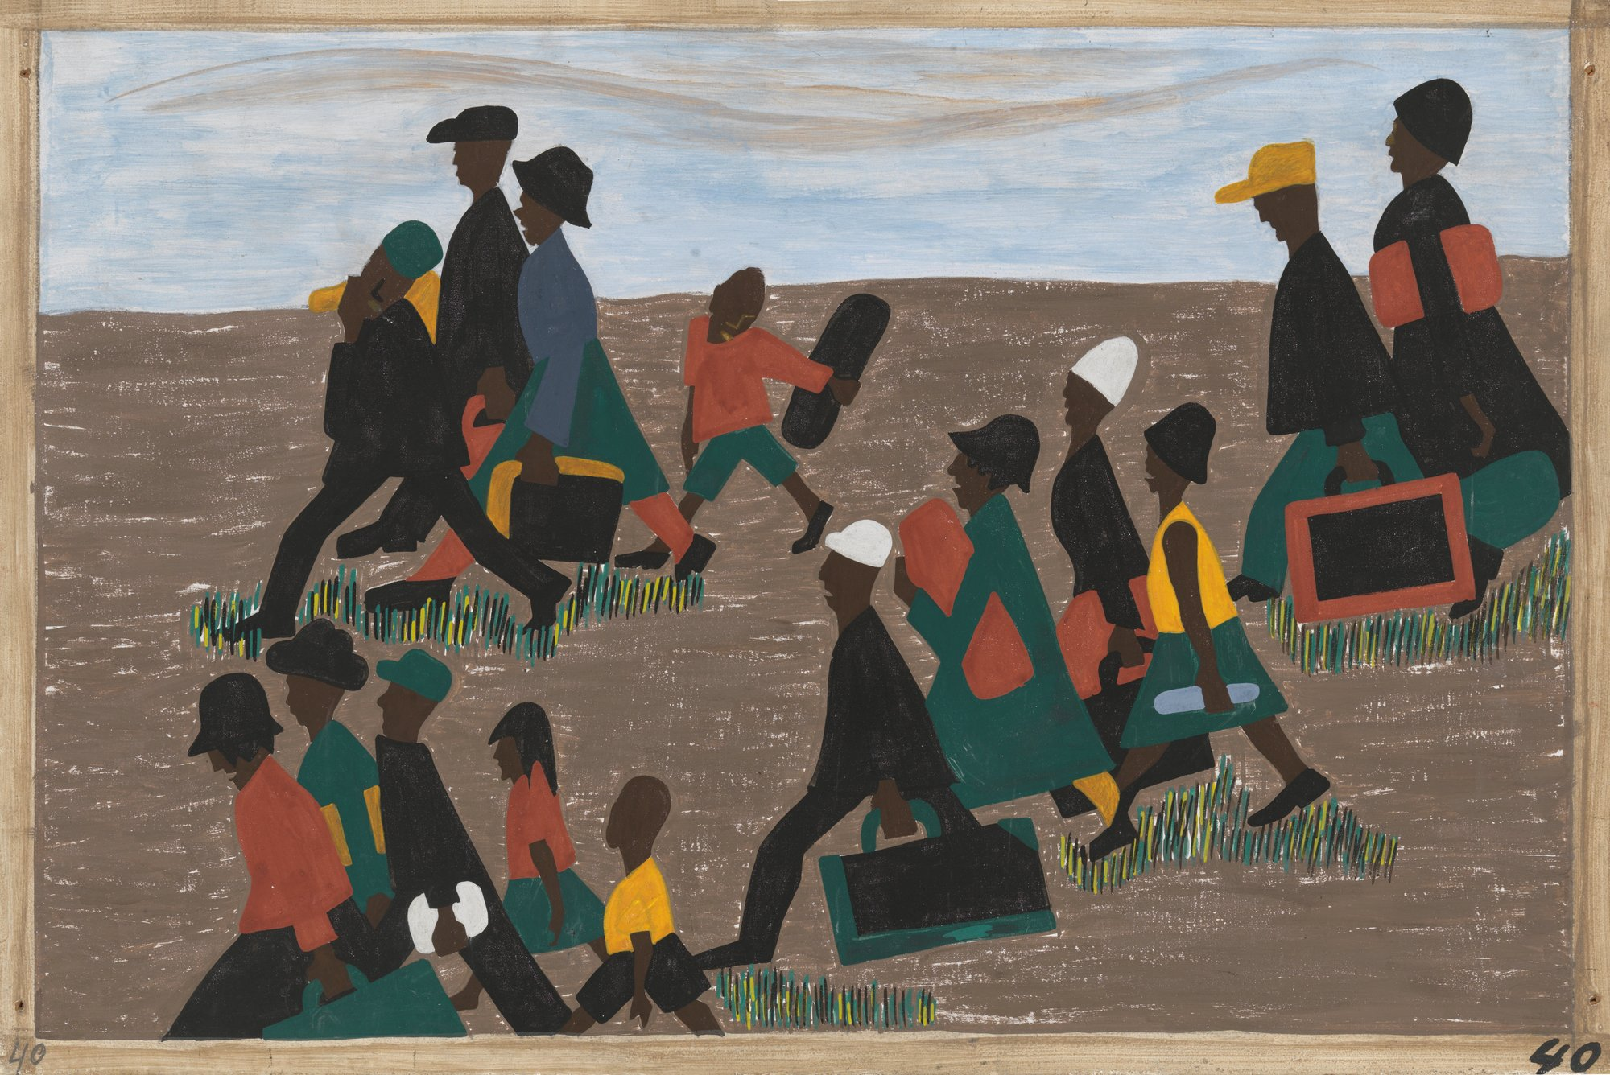
Jacob Lawrence Migration Series, USA, 1940-41
https://www.moma.org/artists/3418?locale=en

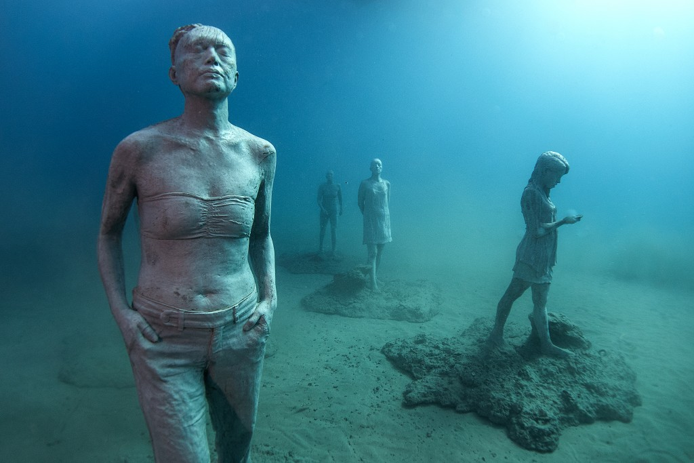
The Raft of Lampedusa James deCaires Taylor (after The Raft of Medusa, below)
http://www.pbs.org/newshour/art/europes-first-underwater-museum-offers-a-stark-reminder-of-the-refugee-crisis/

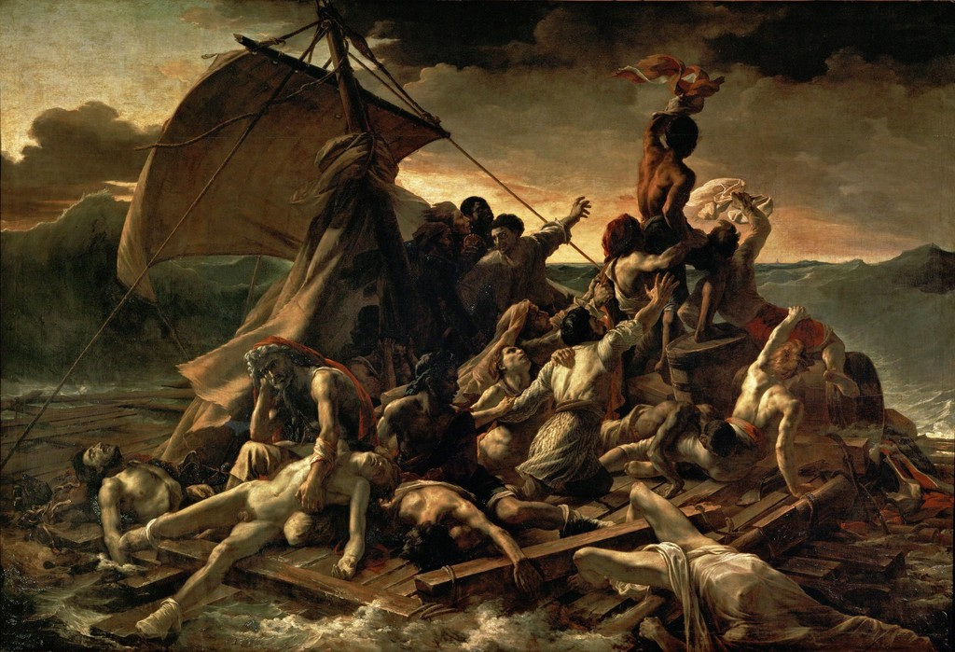
THÉODORE GÉRICAULT The Raft of Medusa 1818-19 the Louvre
https://www.google.co.uk/imgres?imgurl=https://d32dm0rphc51dk.cloudfront.net/bzu8zL8aWfe_lIdZmcB5TQ/larger.jpg&imgrefurl=https://www.artsy.net/artwork/theodore-gericault-the-raft-of-the-medusa&h=699&w=1024&tbnid=94x_ZTGd-RdBYM:&tbnh=160&tbnw=235&usg=__g4WRWLXS66preYWpqGdXrNe7KCQ=&vet=10ahUKEwjP7_P6mubVAhVpIsAKHXfnCwMQ9QEILzAA..i&docid=PzXB33i3Es2VkM&sa=X&ved=0ahUKEwjP7_P6mubVAhVpIsAKHXfnCwMQ9QEILzAA

