**JOMS Poetry Wheel**

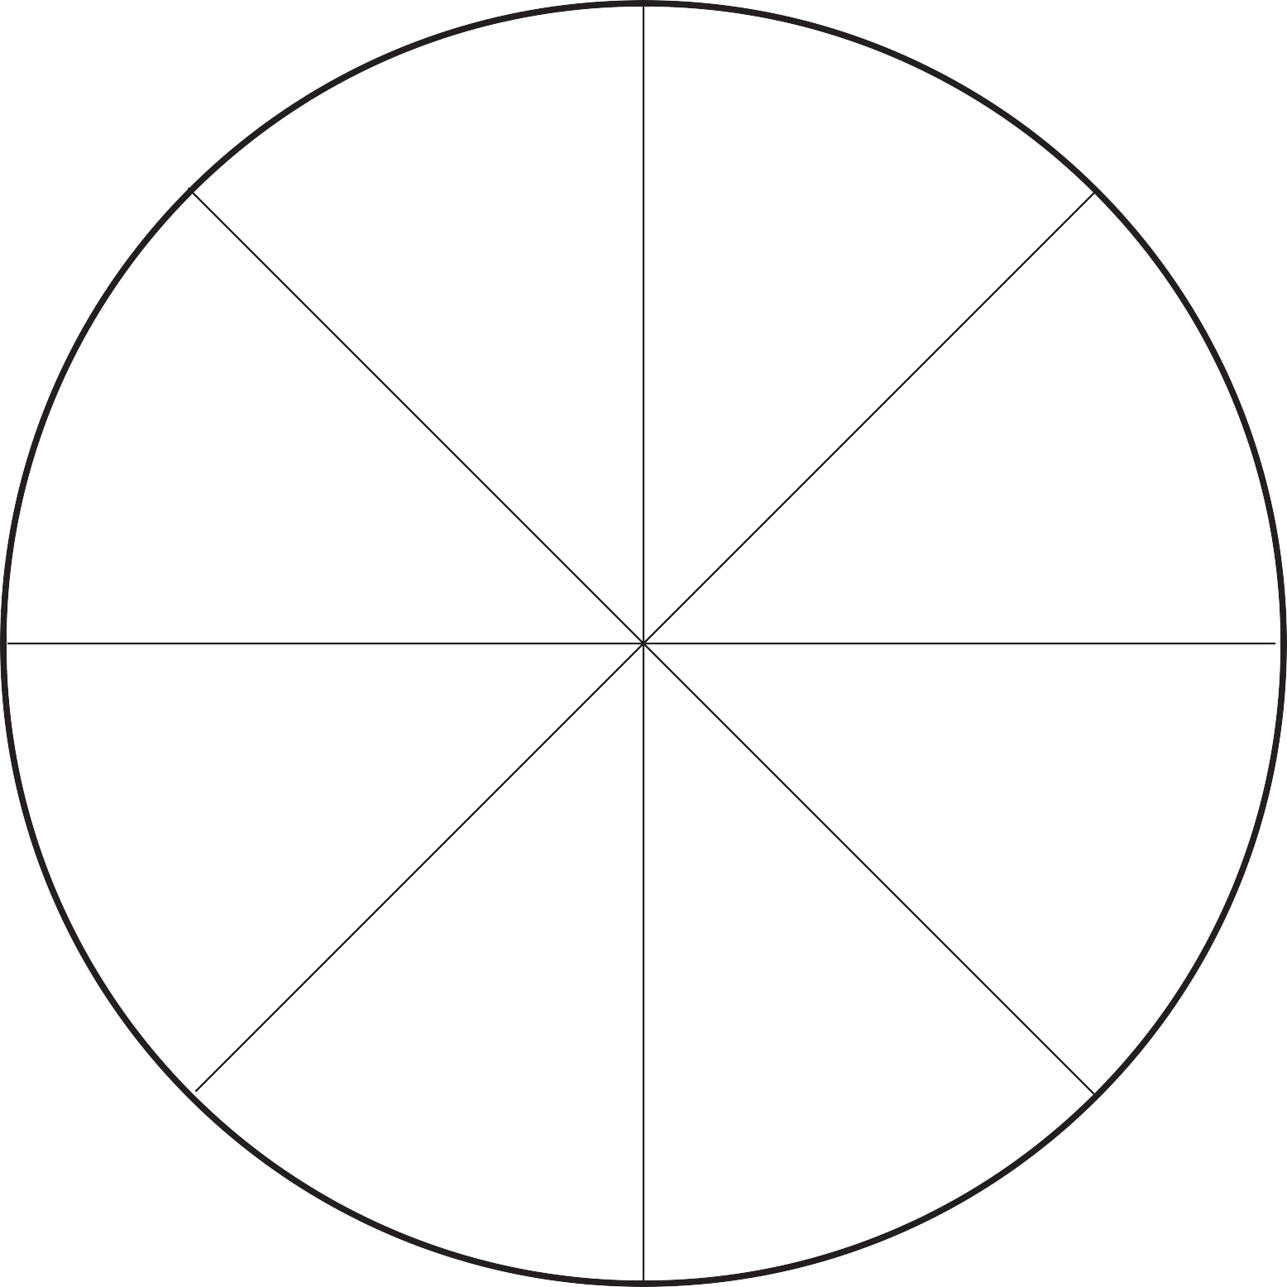

what can you see? 👁

Characters?

♿🕊🚺

any feelings, words spoken

or thoughts? 🎔🗣🗪

any rhyming words?…..

❓…..❓

👂 what can you hear?

where is it

happening? 🌏

anything else ?

what can you taste,

touch, smell? 🗢**🖐**